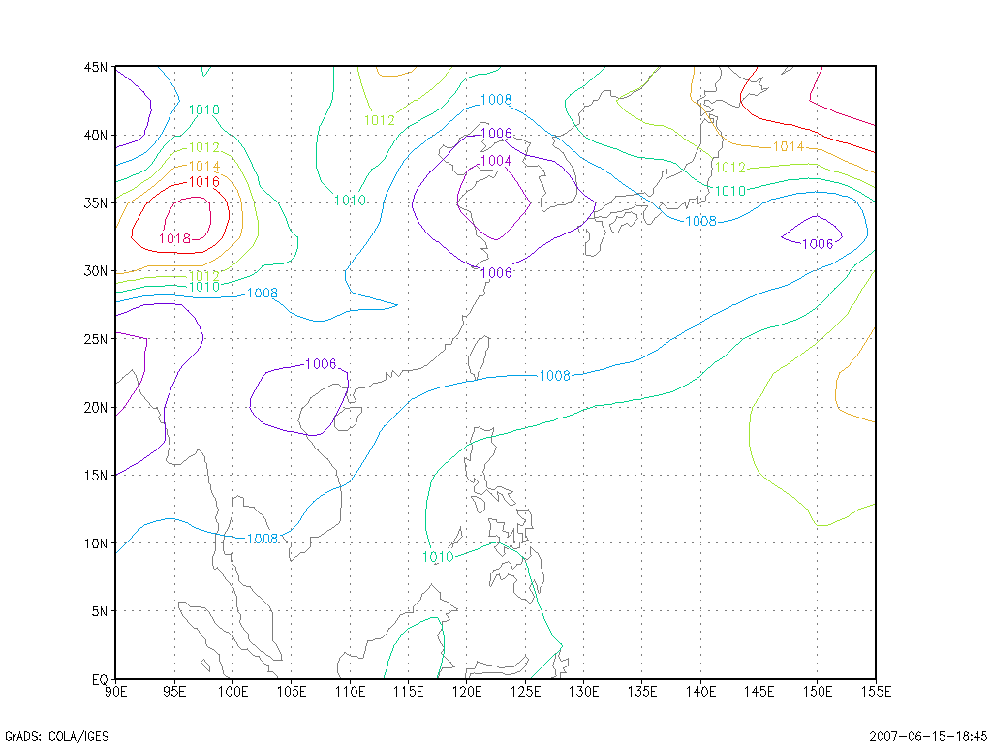
120 hr forecast PRMSL based on N/N Reanalysis data dated 2007060100UTC
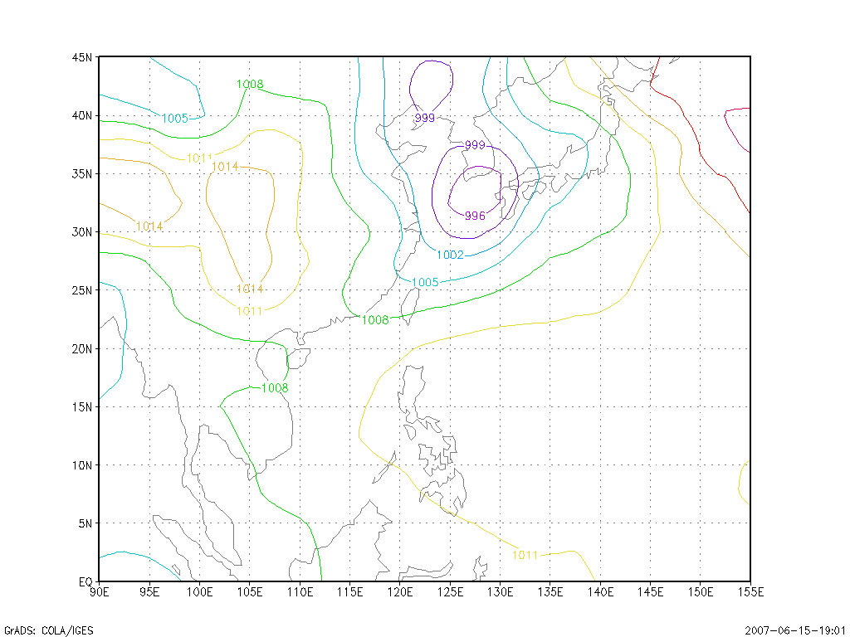
120 hr forecast PRMSL based on GFS output dated 2007060100UTC
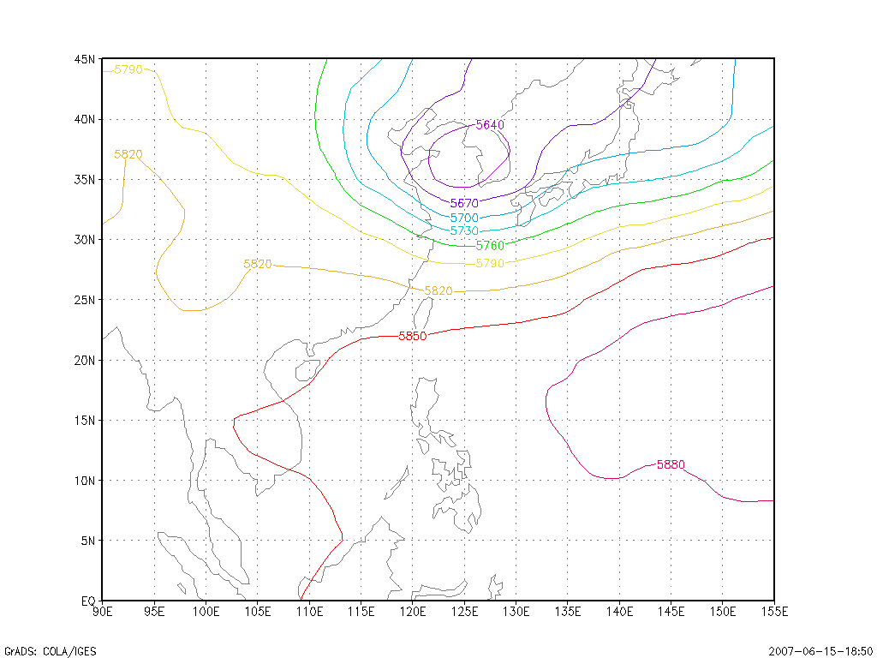
120 hr forecast 500 hPa GPH based on N/N Reanalysis data dated 2007060100UTC
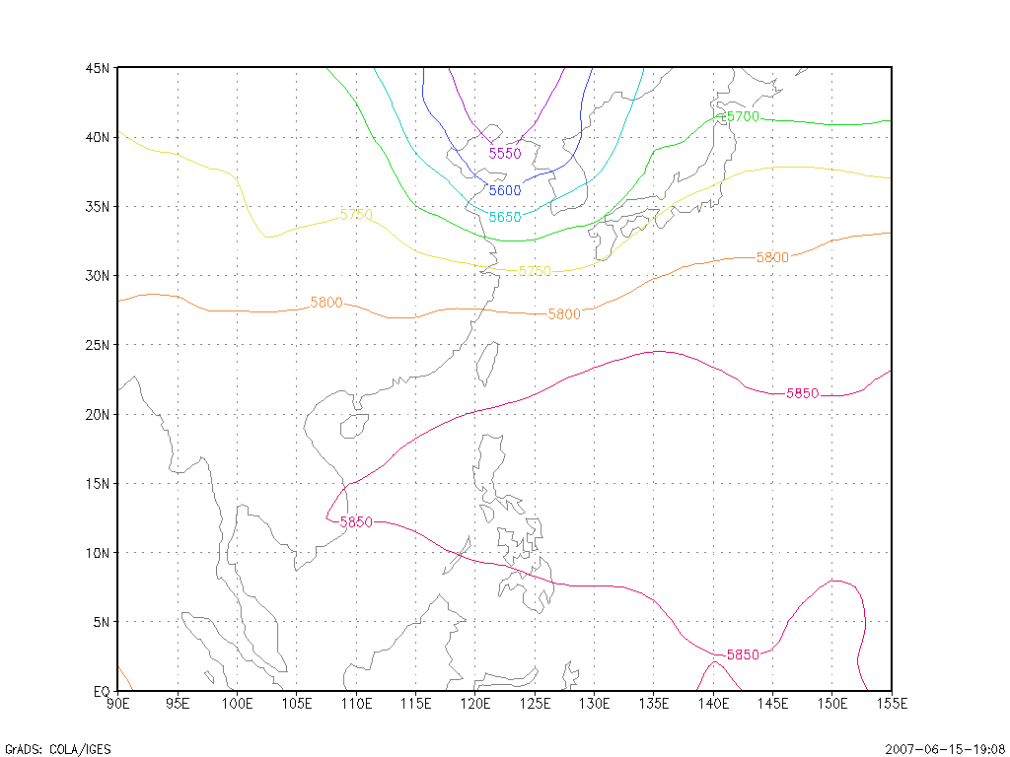
120 hr forecast 500 hPa GPH based on GFS output dated 2007060100UTC
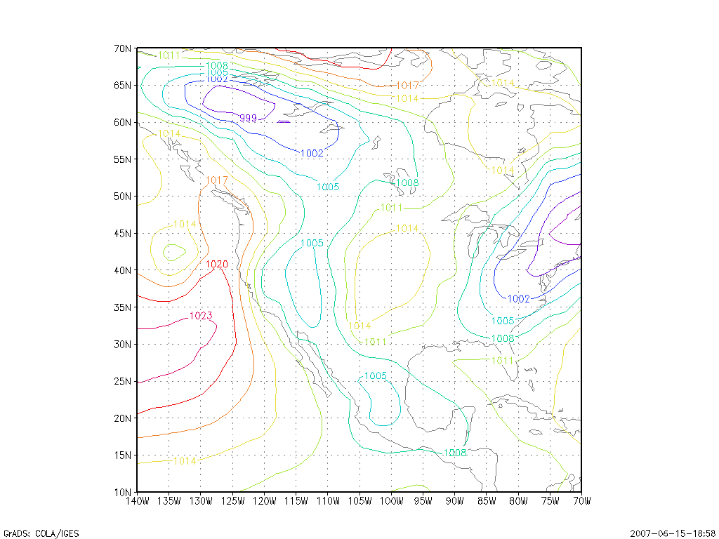
120 hr forecast PRMSL based on N/N Reanalysis data dated 2007060100UTC
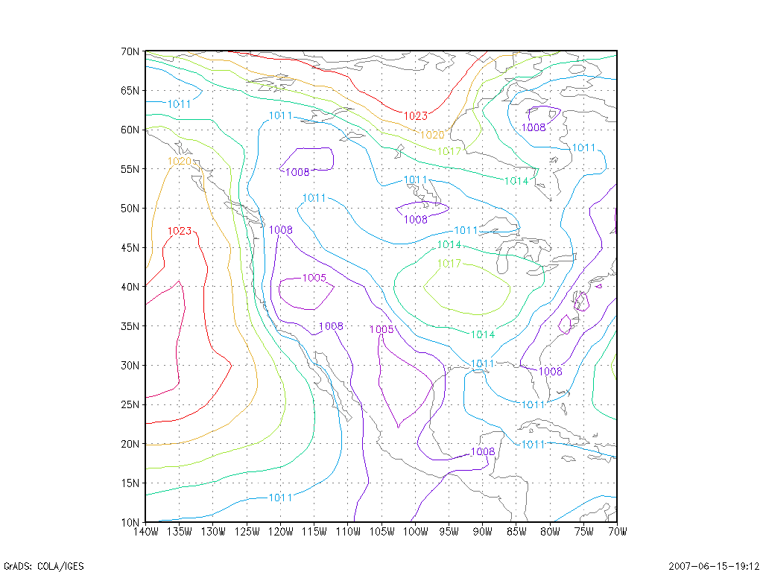
120 hr forecast PRMSL based on GFS output dated 2007060100UTC
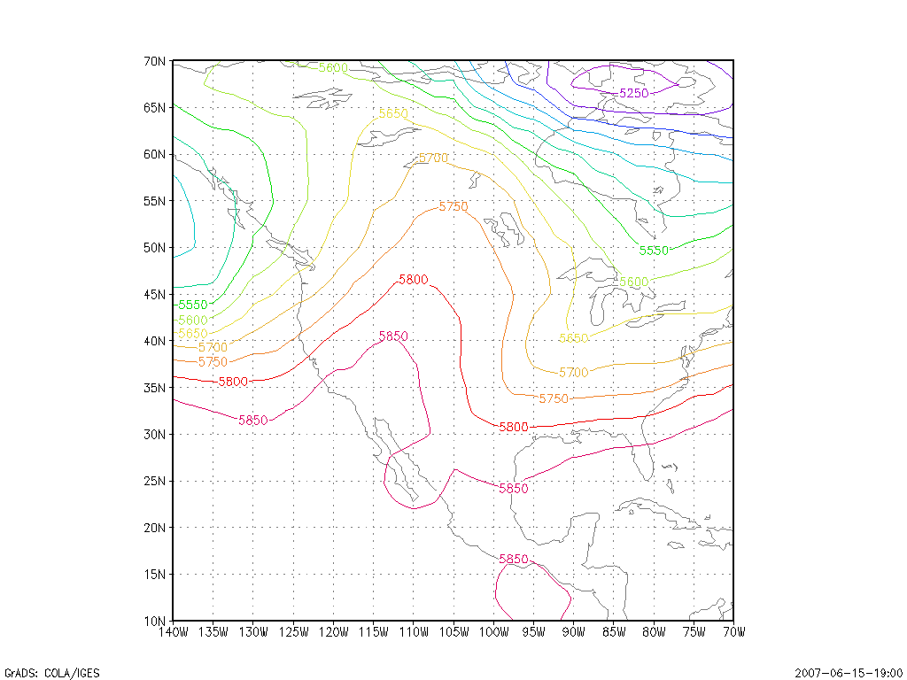
120 hr forecast 500 hPa GPH based on N/N Reanalysis data dated 2007060100UTC
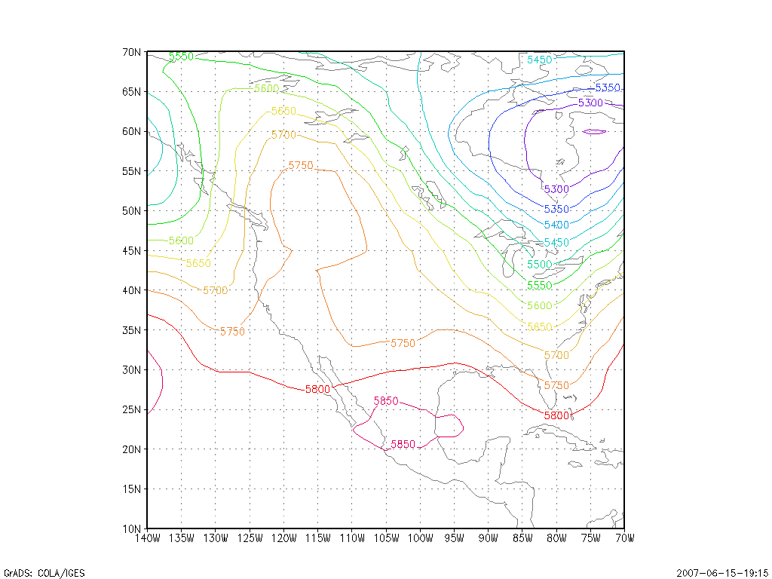
120 hr forecast 500 hPa GPH based on GFS output dated 2007060100UTC

