Specification of External Forcing Fields for Regional Model Integrations

K. Yoshimura^{1,2} and M. Kanamitsu¹

¹Scripps Institution of Oceanography, University of California San Diego
²Institute of Industrial Science, The University of Tokyo

To be submitted to Monthly Weather Review

As of 2008/03/20

Corresponding author:
Kei Yoshimura (k1yoshimura@ucsd.edu),
CRD/SIO/UCSD MC0224, 9500 Gilman Dr., La Jolla, CA92093-0224, USA

ABSTRACT
The effect of the vertical and time interpolation of external forcing on the accuracy of the regional downscaling is examined in this study. To improve the simulation particularly when the forcing field is given at coarse vertical resolution and at lower time frequency, an incremental interpolation method is introduced.
The control experiment is performed by using the forcing at regional model sigma levels, which are exactly the same between the external forcing and the forecast model used. The experimental runs were made from various runs for which the external forcing fields at varying number of pressure levels are interpolated to the regional model coordinate levels.
Two regional model lateral boundary treatment are considered; one with conventional lateral boundary nudging within the specified lateral boundary zones, and the other with spectral nudging which utilize external forcing over the entire domain.
The main result of the full pressure to sigma level interpolation experiment is that the spectral nudging is very important in improving the regional model simulation, but reasonably large number of forcing field levels, at least up to 9 levels, are required to make acceptable regional simulations. If conventional lateral boundary nudging without spectral nudging is used, the accuracy of the regional simulation becomes relatively insensitive to the number of forcing field levels, producing relatively more accurate simulation than spectral nudging when less than 9 forcing field levels are used. However, for the better simulation, it is desirable to have as many forcing levels as possible.

The incremental interpolation in the vertical significantly improves the regional simulation at all number of forcing field levels, but the improvement is most significant at very low vertical resolution. The incremental interpolation in time also works excellently, allowing the use of daily output for reasonably accurate downscaling. By the use of the combination of spectral nudging and incremental interpolation in time, it is possible to make reasonably downscaling from the forcing given daily and at 3-5 levels in the vertical.

1. Introduction
Regional numerical forecast model requires time varying lateral boundary conditions or external forcing. For the regional model that uses any form of spectral nudging to reduce the systematic error of the model (von Storch et al 2000; Kanamaru and Kanamitsu 2006), the external forcing are required not only at the lateral boundaries but also over the entire regional domain. For regional model integrations, these forcing fields are taken from the larger scale and model forecasts or analysis, either from global model or coarser resolution regional model that covers the area. The latter method is known as a multiple nesting.
Since the horizontal resolution and the level specification of external forcing and those of the regional model are generally different, the forcing fields at the lateral boundary or within the regional domain require horizontal and vertical interpolations. Until now, these interpolation processes have not been studied well, probably because they are considered to have minor influences on the regional simulation. This may be true for short range regional forecast problem for which the initial condition is more important and forecast is considered to be accurate until the effect of the lateral boundary start contaminating the forecast in the interior. However, the lateral boundary condition may have significant influence in the downscaling on climate time scale, where the lateral boundary condition continuously influences the interior of the regional domain. The external forcing will be even more important if the it is used within the regional domain.
We can simply surmise several apparent impacts of lateral boundary specification on the regional simulation. The imbalance between wind and mass field at the lateral boundary may likely to excite external gravity waves, contaminating the integration within the domain. The bias in the regional model climatology and lateral boundary forcing might cause significant deterioration in the simulation (Misra and Kanamitsu, 2002). Again, these impacts will be much more significant when spectral nudging is applied since the forcing fields are used within the entire regional domain.
There is no study that suggests the minimum number of levels required for proper lateral boundary condition for regional models. The placement of levels, such as in the stratosphere, near the tropopause and in the boundary layer may cause significant impact on regional simulation, but no systematic evaluations of those have been performed. In fact, the number of forcing levels and time frequency has been somewhat arbitrarily chosen from computer storage limitations. This practice frequently restricts the cases downscaling can be performed. For example, CMIP2 outputs suitable for downscaling are limited to certain models which are requested to provide very large amount of outputs for special predetermined downscaling research.
In this paper, we will examine the impact of the specifications of forcing, especially the influence of the vertical interpolation and the number of levels the forcing is given. We will also present the importance of the time frequency of the forcing. We then introduce a method to improve vertical and time interpolation. This method is to utilize global (or coarse resolution regional) forecast model guess to increase the accuracy of the vertical and temporal interpolation, and allows using relatively small number of forcing levels and lower frequency outputs to produce reasonably accurate downscaling.
In this study, we realize that the treatment of lateral boundary is very different from model to model and the results are strongly dependent on the way lateral boundary conditions are treated. Namely, the width of the relaxation zone, the magnitude of relaxation and the way relaxation is applied are very different. The use of spectral nudging (von Storch et al 2000; Kanamaru and Kanamitsu, 2007) makes the specification of outer model fields more critical, since large scale part of the outer model is used within the regional domain. Because of this, we decided to perform two experiments, one using conventional lateral boundary zone nudging without any forcing within the domain and the other using spectral nudging, hoping that the result of this paper be used widely to a variety of regional models.

2. Global and regional models
The Scripps ECPC global and regional spectral models (GSM and RSM) are used in this study. ECPC GSM was based on the medium range forecast model used at NCEP for making operational analysis and predictions (Kanamitsu et al., 2002a). The physical processes in the GSM and RSM are identical for this study, which are similar to those in NCEP/DOE Reanalysis 2 project with some updates associated with the use of a Relaxed Arakawa-Schubert deep convection scheme (RAS; Moorthi and Suarez, 1992) and the Noah land surface scheme (Ek et al., 2003). As an operational global weather forecast model, the basic performance of the NCEP GSM suites have been documented well (e.g., Caplan et al., 1997, Kanamitsu et al., 2002) and have shown comparable performance in several global model intercomparison studies (e.g., Kang et al., 2002). We chose T62 horizontal resolution (about 200 km) and 28 vertical sigma levels, same resolution as the R2, for the global model integration. The sea surface temperature and ice distribution used in Reanalysis 2 were applied as lower boundary conditions.
The RSM also has been tested in many downscaling studies including the recent 57-year California Reanalysis Downscaling at 10 km scale (CaRD10, Kanamitsu and Kanamaru, 2007). A unique aspect of the model is that the spectral decomposition is applied to the difference between the full field and the time-evolving background global analysis field.
The RSM was integrated with two different lateral boundary treatments: 1) applying conventional nesting method, using wide enough lateral boundary nudging zones, but leaving the interior of the domain free of any forcing and 2) applying a spectral nudging scheme that forces large scale within the domain to be that of the outer boundary (SSBC, Kanamaru and Kanamitsu 2007, hereafter SSBC07). The latter allows the use of narrower lateral boundary nudging zones and weaker nudging coefficient, It is noted that based on a large number of sensitivity experiments, the SSBC has been improved from the original form proposed by Kanamaru and Kanamitsu (2007) by the following changes : 1) only rotational part of wind is spectrally nudged, 2) only area averaged temperature is corrected and 3) nudging of humidity is removed. Should we show some results in Appendix?

3. Design of experiments
The control experiment (CTL) is an integration of the regional model using the lateral boundary conditions taken from the global model, whose vertical level is placed exactly the same as that of the regional model. The difference in the topography between low resolution global and high resolution regional models require vertical interpolation (due to the difference in surface pressure), but the difference of pressure in two model levels are never too large (maximum pressure difference is of the order of ?? hPa). In our program, spline interpolation is used for this procedure. For conventional pressure to sigma interpolation experiment (P2S), data are log linearly interpolated from selected standard pressure levels to model sigma levels.
The number of pressure levels and their placements examined in this study are:
1) 17 levels (17L, 1000~10 hPa), (Specify levels)
2) 9 levels (9L, 1000~200 hPa), (Specify levels)
3) 7 levels (7L, 850~200 hPa), (Specify levels)
4) 3 levels (3L, 850, 500, and 200 hPa),
5) 2 levels (2L, 850 and 200 hPa).

As mentioned in the introduction, the two different treatments of lateral boundary condition are used; 1) conventional lateral boundary nudging with wider lateral boundary zones (BN), and 2) weaker lateral boundary nudging with narrower nudging zone and spectral nudging (SN).
The domain of the experiments covers a part of North and Central Americas including US and Mexico, (135-65W and 10-50N), with 50 km horizontal and 28-level vertical resolutions. The integration period is January 1-11, 1985. Each set of experiments consist of 4 ensemble members that start 00Z on 1st, 2nd, 3rd, and 4th, respectively, and all end at 00Z January 11. These ensemble integrations are used to obtain statistical significance of the difference between the experiments. The last 4-day averages (00Z 7th to 00Z 11th January) are used for all the investigations described below.
For the quantitative measure of the goodness of the specification of the lateral boundary condition, we used the differences of near surface temperature, wind and precipitation between the CTL and the experimental runs. These quantities are chosen since they are most frequently utilized in application studies. Note that there are two CTLs for two different lateral boundary treatment, i.e. BN and SN, which are significantly different (Figure ? May be an appendix?), and we used respective CTL for the computation of differences.

4. Number of vertical levels of the forcing fields

4.1 Results from conventional lateral boundary nudging integrations.
Dark bars in Figure 1 present comparison of the root mean square difference (RMSD) between the CTL and experiments with 3 different forcing level specifications (17, 9 and 3 levels) for conventional lateral boundary nudging. The left most bars, the mean RMS among the ensemble members, indicates the variance of the simulations due to the difference of initial conditions. This variability is considered to be the difference due to unpredictable or uncontrollable part of the control regional simulation and all the difference with experiments are compared against this variability to measure the statistical significance of the differences. The figure shows that for the 2-meter temperature, the RMSD increases steadily from 17 levels to 3 levels. For 3 levels, the RMSD reaches 1.8C. For the 10-meter wind speed, the RMS seems to level off at 9 levels. Contrary to temperature and winds, precipitation is much worse even for 17 levels, but 3-levels is much worse. In summary, when the conventional lateral boundary nudging is used, it is desirable to use as many levels as possible from forcing field.

4.2 Results from spectral nudging integrations.
Dark bars in Figure 2 show the results from the same experiments as section 4.1 but using spectral nudging (SSBC07). It is clear that the spectral nudging provides smaller RMSD than the lateral boundary nudging for the number of forcing field levels larger than or equal to 9, indicating the usefulness of using spectral nudging. On the contrary, the RMSD of spectral nudging for levels less than or equal to 7 is much larger than the RMSD of conventional lateral boundary nudging. This seems to indicate that the spectral nudging depends strongly on the accuracy of the forcing field, which is less accurate if interpolated from smaller number of forcing field levels. This is expected since the spectral nudging utilizes the forcing field within the domain. For the conventional lateral boundary nudging, the result is not so sensitive to the outer model levels since they are used only at and near the lateral boundaries. The huge discontinuity between 9L and 7L is not simply a result of the lack of lowest-level forcing field, but a combination of the lack of models at lower and upper levels. The RMSD of experiment with 6L with two lower levels (at 900 and 1000hPa?) was found to be as large as that of 7L, suggesting that the lack of lower levels is not essential for the degradation. Interestingly, 17L is slightly less accurate than 9L in the experiment. We do not know the reason at this point, but we suspect it is related to the balance between wind and mass field.
From those experiments, we came to the following conclusion when the spectral nudging is applied. The spectral nudging improves the regional simulation compared to conventional lateral boundary nudging, if sufficient number of levels are given to the forcing field. If the forcing field vertical resolution is poor, the regional simulation deteriorates and become worse than the cases with simple lateral boundary nudging. The vertical resolution of forcing field is critical to the quality of the regional simulation when spectral nudging is used, and it requires at least 9 levels. The specification of the levels in the vertical is not so critical, but evenly distributed levels in the vertical are preferred.

5. Incremental interpolation
In the previous experiments, vertical interpolation was performed using full forcing fields at given pressure levels. Since no information is available between the given pressure levels, the vertical scale less than the pressure level thickness cannot exist. The pressure level output most commonly utilized in downscaling is usually produced from model forecast or data assimilation system. These outputs are produced by interpolating the fields from model coordinate surfaces to specific standard pressure levels. Since the models tend to have very high vertical resolution in the planetary boundary layer (and other levels, such as in the stratosphere and near the tropopause levels in some models), the vertical interpolation to coarser pressure levels tend to lose high vertical resolution information during the interpolation process. In order to avoid this loss, some downscaling project requires forcing field output to be in very high pressure level resolution, of the order of 25 hPa. This requirement increases the amount of model output, burdening the global model simulation producers. In addition, 25 hPa may not be still sufficient for resolving fine vertical structure in the planetary boundary layer. Thus, it is of great convenience if there is a way to recover fine scale vertical structure given coarse vertical resolution fields.
In this section, we propose a method to recover such fine vertical scale structure and examine how such procedure can improve the regional simulation. The method we introduce here is a common procedure used widely in objective analysis, called incremental interpolation (Ref.). This method uses short range forecast with global coarse resolution model (or regional coarse resolution model covering the area larger than the area in consideration) as a guess and vertically interpolates the difference between external forcing field and guess at the model levels. Since only the increment is interpolated, the fine structure in the guess field is preserved after the interpolation. Note that in the extreme case of no observation, the fine scale detail in the initial guess field is preserved. For avoiding the model inconsistencies, the global model or the coarse resolution regional model to produce guess field should be as close as possible to the regional model used for downscaling in terms of model vertical resolution, level placement, numerics and physical processes.
In our study, the interpolation of increment is performed in the following manner:
- Run a global model and generate a guess for specific time ahead. This guess is full-level global data.
- Interpolate the guess at model sigma levels to standard pressure levels where the pressure level data are available.
- Calculate the difference (increment) between the guess and pressure level data at given pressure levels.
- Interpolate the increment from pressure level to sigma level
- Add interpolated increment to guess at the sigma levels.
- Go back to process 1 using the incremental interpolated data as an initial condition.
The computational procedures and the concept of incremental interpolation are schematically illustrated in Figure 3 and 4. The incremental interpolation can also be applied for temporal interpolation, as schematically drawn in Figure 5. We will discuss the result of the temporal interpolation in Section 6. The diagonally shaded areas in these figures are the “increments” and they are added to the full field guess, so that vertical or temporal details remain in the data.
White bars in Figure 1 present the result of incremental interpolation for conventional nudging in the lateral nudging zone. It shows very clear improvement of reducing RMSD at least up to 9 pressure levels. Small improvement can be seen for 3 level experiment.
White bars in Figure 2 present the same result for the cases with spectral nudging. The incremental interpolation significantly improves regional simulation for nearly all the range of pressure levels. From practical point of view, the number of pressure levels of about 5 is sufficient to obtain reasonably accurate regional simulation, but even 3 levels produces reasonably good regional simulation. An example of the comparison of the geographical distribution of 2-meter temperature, 10-meter wind and precipitation are shown in Figures 6, 7 and 8. We should note that the improvement is more apparent for 2-meter temperature and 10-meter winds but not so much for precipitation.
The above results are somewhat biased toward the forecast model used, since the forcing, Reanalysis-2, utilized an older version of the forecast model used in this study. The difference in the model is fairly large, which include the convective parameterization of SAS vs. RAS, long wave radiation of Schwartzkopf and Fels vs. Chow schemes, and OSU vs. Noah land schemes. However, the model numerics and other components are similar. In order to examine the model that generates guess, we repeated the experiment using MIROC simulations. PLEASE EXPLAIN MIROC, AND WHAT SIMULATION IS USED TO DOWNSCALE. In this case, the model that produced the simulation is completely independent from the model used in downscaling. In this experiment, we used the downscaling made from ?? levels of forcing as a control and made two runs, 7L and 3L and compared. Figure 9 shows RMSD against control. The incremental interpolation apparently significantly improves the simulation compared to full field interpolation, both for 7L and 3L experiments. Thus the improvement due to the use of forecast guess created by independent forecast model is still very significant. If compare the RMSD with those from experiments discussed previously, the disagreement is somewhat greater for the current experiment (about 1.5 to 2 times greater than the previous experiments). Note that this comparison may not necessarily justified since the basic states or the two experiments are very different.
The shortcoming of the incremental interpolation is that it requires global forecast model integration. However, since the integration of coarse resolution global model is fairly inexpensive compared to the regional model, the overhead for incremental interpolation is probably of the order of 10-20%, but this is strongly dependent on the regional model domain size and resolution.
The relation between incremental interpolation and double nesting should also be noted here. From incremental interpolation point of view, double nesting is exactly the same as producing guess field at the lateral boundaries but use the guess as lateral boundary values for regional model integration without correction. The incremental interpolation method corrects the guess using pressure level values from forcing field levels at the given lateral boundary location, which should better agree with external forcing fields. In this sense, the double nesting is a version of the incremental interpolation without using pressure level data.

6. Time interpolation
In this section, the effect of the time interval of the outer model data is examined. The same experiments described in sections 4 and 5 are repeated but the forcing fields are provided every 24 hours in stead of 6 hours. The experiments consist of various forcing field vertical resolutions, from full 28 sigma levels to 17, 9, and 3 pressure levels. In order to simplify the experiment, we performed the downscaling with spectral nudging only and with incremental interpolation in the vertical.
The incremental interpolation in time is performed by linearly interpolating the increments at 24 hours into 6 hourly interval and adding it to the forecast at corresponding forecast hours (see schematic explanation in Figure 2).
Figure I shows the results. The RMS errors are only calculated at 00Z on each day. In the figures, the incremental interpolation in time worked quite efficiently to reduce the errors in surface temperature and wind for all experiments, even for the runs using the full 28-levels. Even though the RMS errors did not dramatically drop in precipitation by the incremental time interpolation, it worked positively to make the averaged precipitation closer to the CTL simulations.
Overall, these experiments suggest that we should use incremental interpolation in time if only daily data are available.

7. Summary and Conclusions
In this study, we examined how the external forcing affects the accuracy of the regional downscaling. We also introduced an incremental interpolation method to improve the simulation particularly when the forcing field is given at relatively less number of levels and at lower time frequency. The models used in this study are the ECPC global to regional spectral model (G-RSM). The experiments were run over continental U.S. with 50km resolution using Reanalysis-2 as a forcing, but the results will not vary significantly if other location, resolutions and forcing are used.
The control experiment is performed by using the forcing at regional model sigma levels, which are exactly the same between Reanalysis-2 and the forecast model used in this study. The experimental runs were made from various runs for which the Reanalysis-2 at various number of pressure levels are interpolated to the regional model sigma levels.
Two regional model lateral boundary treatment are considered; one with conventional lateral boundary nudging within the specified lateral boundary zones, and the other with spectral nudging which utilize external forcing over the entire domain.
It was found that for the full field vertical interpolation, the spectral nudging is very important in improving the regional model simulation, but fairly large number of forcing field levels, at least up to 9 levels, are required to make reasonably accurate regional simulations. When conventional lateral boundary condition and nudging is used, it is desirable to have as many forcing levels as possible, however, the accuracy of the downscaling is relatively insensitive to the number of forcing field levels, and provides relatively more accurate simulation than spectral nudging when less than 9 forcing field levels are used.
The incremental interpolation in the vertical significantly improves the regional simulation at all number of forcing field levels, but the improvement is most significant at very low number of levels. Even 3 forcing field levels is sufficient to produce relatively accurate regional simulation. The incremental interpolation in time also works excellently, allowing the use of daily output for reasonably accurate downscaling.
Additional incremental interpolation experiment for the downscaling of MIROC simulation demonstrated that the method works for the downscaling of coarse resolution simulation/analysis which are completely independent from the model used in downscaling and guess generation.
The improvement is apparent for 2-meter temperature and 10-meter winds, but not so significant for precipitation. The work to examine the cause of this difference in impact is left for future.

Acknowledgments:

APPENDIX A: Departure from base global data evaluated by 500 hPa height
Figure A1: 500Z departure. The reproducibility of the large scale fields among the method using the same data are compared. NDG is generally better than NST.

REFERENCES
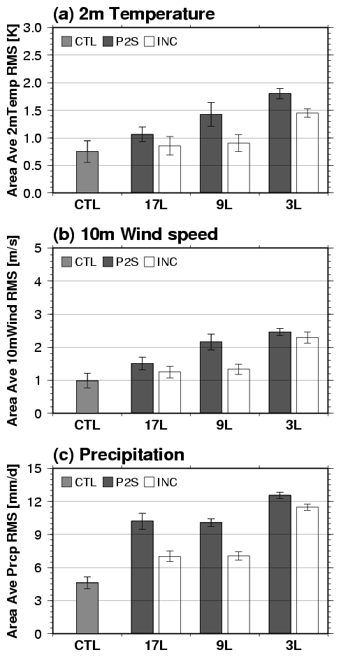
Figure 1. Ensemble means of area averaged RMS between CTL (the experiment with full level analyses) and experiments with different number of analysis vertical levels without spectral nudging are shown for 2-meter air temperature (a), 10-meter wind speed (b) and precipitation (c). Dark gray and white bars denote the use of a simple vertical interpolation and an incremental interpolation for the global forcing. Light gray bars indicate RMS between the CTL ensemble members. The error bars indicate standard deviations of the RMS of ensemble members.
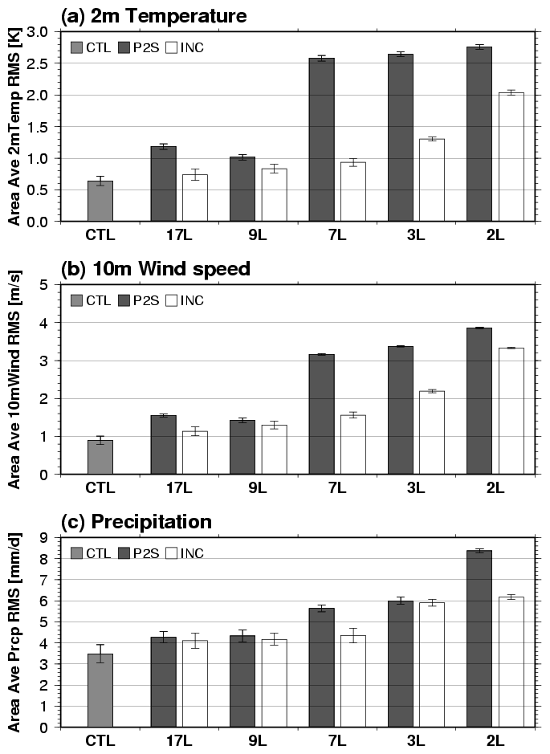
Figure 2. Same as Figure 1 but from the integration with spectral nudging. In this set of experiments, 7 and 2 level cases are added.
Figure 3: Schematic representation of the computational procedure of the increment interpolation scheme.
Figure 4: Schematic representation of the vertical incremental interpolation.
Figure 5: Schematic representation of temporal incremental interpolation.

Figure 6: 4-member ensemble mean of 4-day averaged surface air temperature using the spectral nudging (NDG) is shown by contours, and the difference from the downscaling results with full level analysis (CTL) is shown by shades. A linear interpolation of the global analyses with limited number of vertical levels was used to make global base data for P2S experiments (a and c), whereas the incremental interpolation scheme (IIS) was used for INC experiments (b and d). Numbers of the vertical levels used data are 9 levels (1000~200 hPa) for (a) and (b) and 3 levels (1000, 500, and 200 hPa) for (c) and (d).
Figure 7: Same as Figure 4, but for wind speed. The difference between the experiment and the control (shades) is calculated as ((U_{exp}-U_{ctl})²+(V_{exp}-V_{ctl})²)^{1/2}.
Figure 8: Same as Figure 4, but for precipitation.
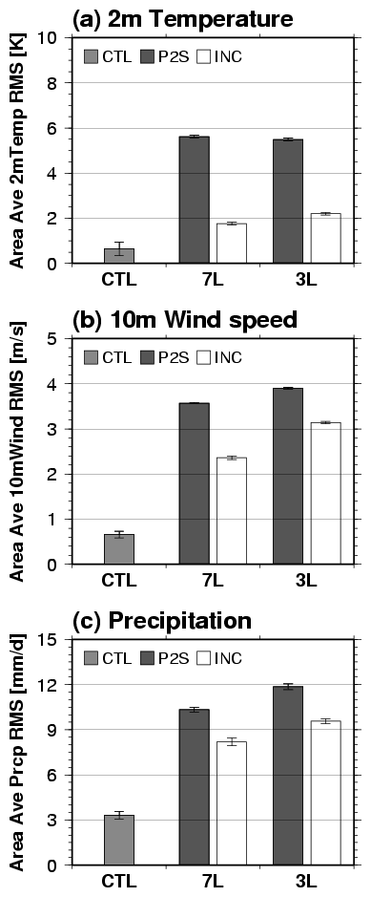
Figure 9. RMSD of 2-meter temperature, 10-meter wind and precipitation between the regional simulations performed by 17 forcing levels and 7 and 3 levels. The values are ensemble mean of 4 members. Dark bar is the experiment using conventional lateral boundary nudging and white bar is with spectral nudging. Control is the RMS of 4 member ensemble.

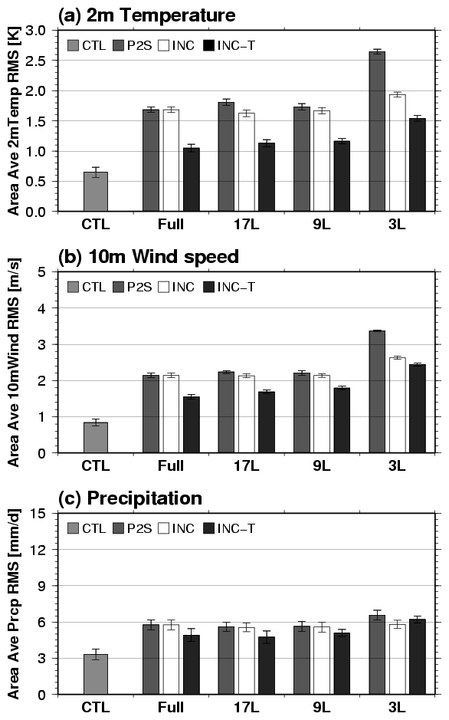
Figure 10: Similar to Figure 2, but comparing daily and temporal incremental interpolation experiments. CTL is the 6-hourly data with full sigma levels. Dark gray bars correspond to full vertical interpolation, while white bars denote vertical incremental interpolation. The black bar is the result of vertical and temporal incremental interpolation. For the full (28 sigma levels) data, the full interpolation and incremental interpolation yield the same result.
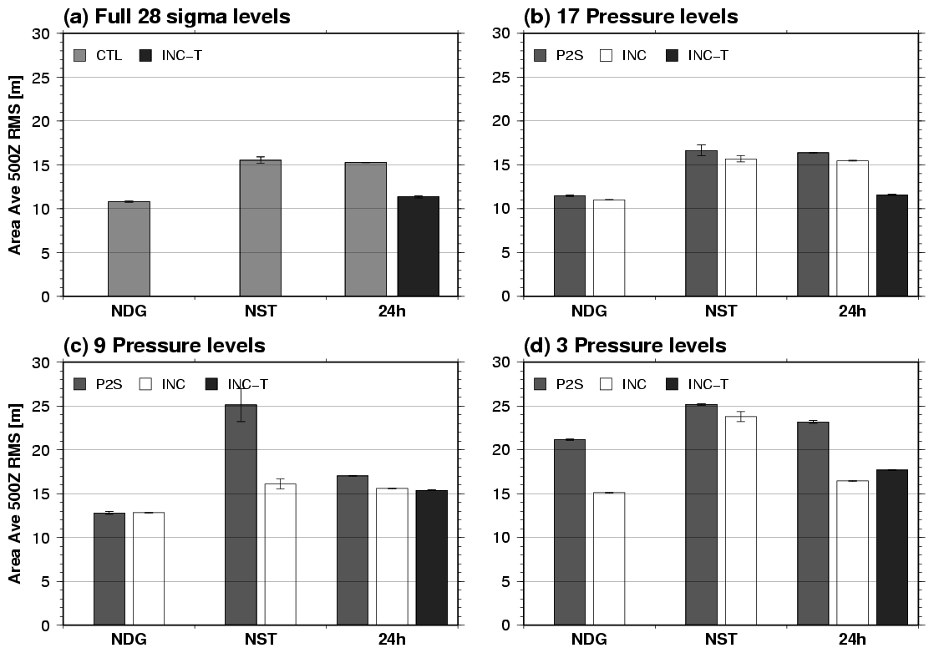
Figure A1: Ensemble mean of area averaged RMS in 500 hPa height between each experiment and the global analysis. The downscaling experiments include: the control experiments using full level analysis data (a); and those with boundary conditions made by the simple interpolation (P2S; dark gray) and the incremental interpolation (INC; white) with using 17-level (1000 ~ 10 hPa) analysis data (b), 9 level (1000 ~ 200 hPa) analysis data (c), and 3-level (1000, 500, and 200 hPa) analysis data. Error bars indicate standard deviations of ensemble members.

