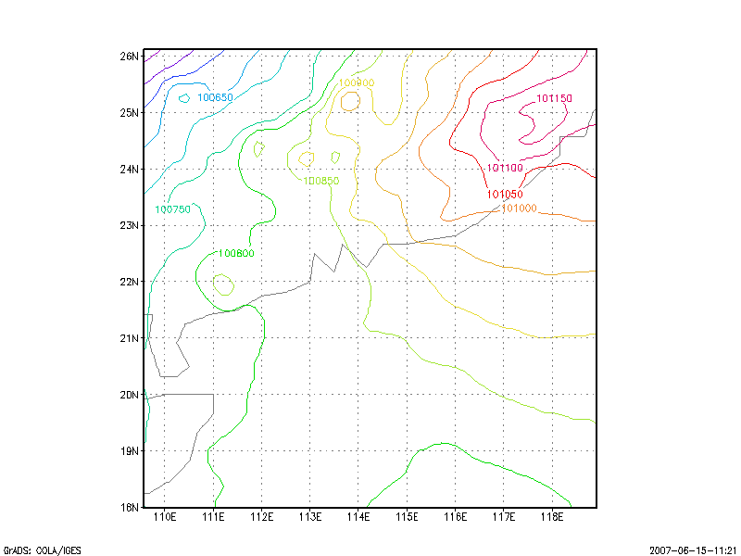
714 hr forecast PRMSL based on 1997 0601 00 UTC – 200706 version of G-RSM
(A ridge of high pressure over southeastern China)
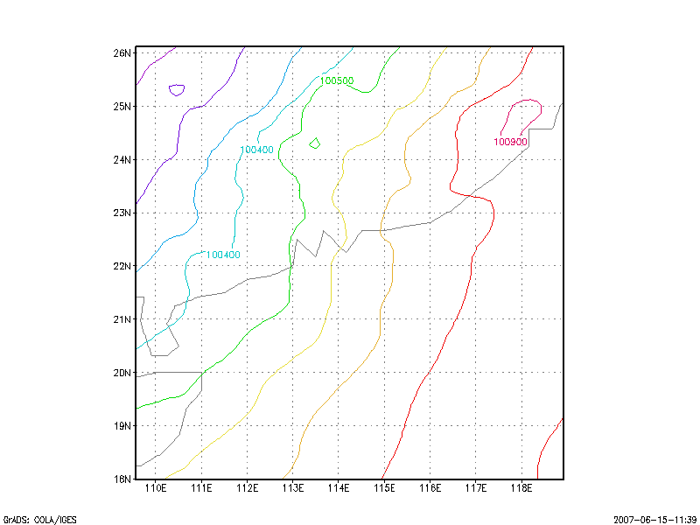
714 hr forecast PRMSL based on 1997 0601 00 UTC – 200611 version of G-RSM
(A southwest monsoon situation over southern China)
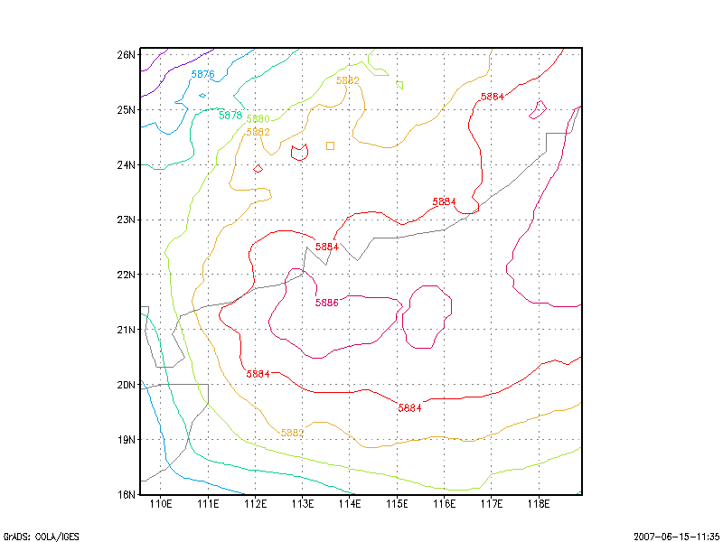
714 hr forecast of 500 hPa GPH based on 1997 0601 00 UTC – 200706 version of G-RSM (the sub-tropical ridge dominating over south China coast and the northern part of the South China Sea)
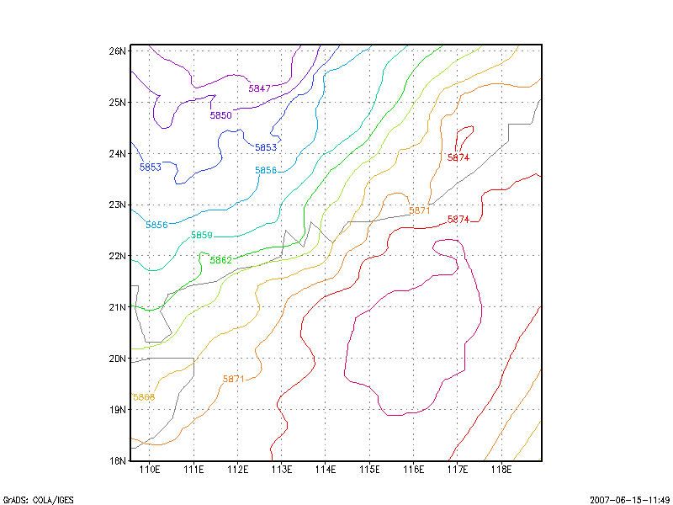
714 hr forecast of 500 hPa GPH based on 1997 0601 00 UTC – 200611 version of G-RSM (A weaker sub-tropical ridge over the northern part of the South China Sea)
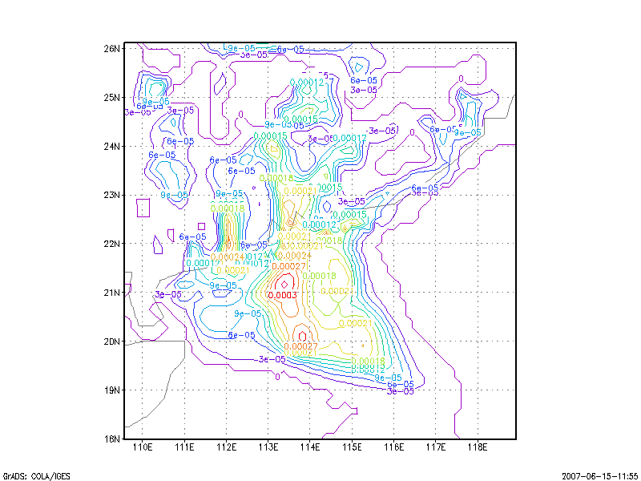
714 hr forecast PRATE based on 1997 0601 00UTC – 200706 version of G-RSM
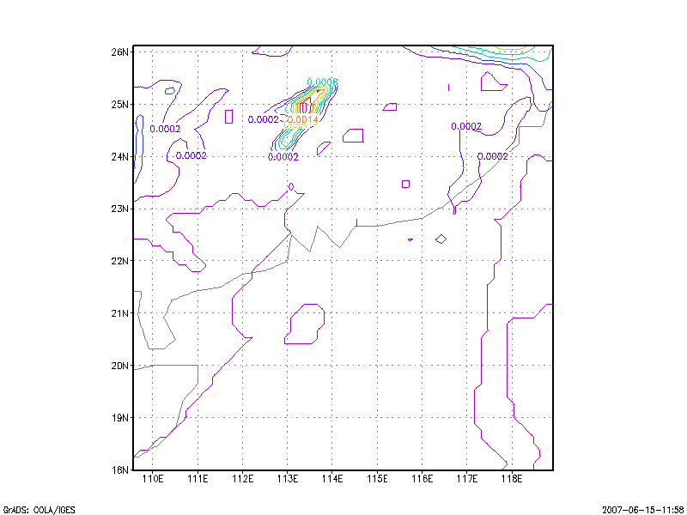
714 hr forecast PRATE based on 1997 0601 00UTC – 200611 version of G-RSM

