GDAS (Global Data Assimilation System)

1. Data assimilation system
The Global Data Assimilation System (GDAS) used here has the same assimilation routines as ones used for NCEP-DOE Atmospheric Model Intercomparison Project (AMIP-II) reanalysis (R-2; Kanamitsu et al., 2002). This system consists of a complex system of data analysis. It has spectral statistical interpolation (SSI) routine related to a three-dimensional variational analysis (3DVAR) (Parrish and Derber, 1992). In addition to SSI module, there are routines for decoding observation data, and quality controls based on the optimal interpolation (OI) and hydrostatic consistency check. Details for the GDAS are described in Kalnay et al. (1996). The GDAS is incorporated into the CVS version of the global spectral model system (Seasonal Forecast Model, SFM). This SFM within the GDAS continues to evolve.

2. Installation

*To install automatically
cvs co install
./install (follow the instruction)

*To install manually
Move to ./libs:
cvs co libs_rsm
cvs co libs_gdas
configure-libs_gdas (after editing it)
make
make gdas

(make clean)

Move to ./gdas:
cvs co src_gdas
configure-model (after editing it)
make
make gdas

(make clean_gsm)
(make clean_gdas)

Move to ./run:
cvs co scr_gdas
configure-scr gdas

*setup for DEC machine
3 files should be substituted in current version. These are not committed in CVS. After entering ./install, replace files below.
./libs/etc/utils/scnvrt.F (and ‘make’) : only for DEC
./gdas/src/sfc0/sfc0.F (and ‘make’)
./runs/runscr/sfc0.in (and ‘../configure-scr gdas’)

*problem in case of using compile flag –i4
If FORT_FLAG=-i4,
then ./gdas/src/ssi/wranlc.F is not compiled,
./libs/lib/bufrlib_dec/datebf.F produces wrong date record.
Record CAT of SATEMP data from ./gdas/src/prevents has wrong value.
But, users should set the compile flag of ./libs/etc/util_dec/Makefile to –i4, so that ‘grmean’ can work well.

GDAS Script
-one time run script ‘gdas’
Variables to modify in gdas.in are as follows.
INPUT_BUFR_FILE_NAME=: input raw bufr file name
INPUT_BUFR_BLOCKING=: There are two options. “no” means it needs to be converted to the machine-dependent bufr file. ”[machine name]” means that machine-dependent bufr file already exists, then just is copied to the run directory.
SIG_GUESS, SFC_GUESS: 6hr fcst first guess sig/sfc data name at the –6hr.
SIG_ANL_PREV: analysis sigma file name at the –6hr.
SST_ANL, SNO_ANL, ICE_ANL: sst, snow, ice boundary files.
YYYS, MMS, DDS, HHS: analysis start time
YYYF, MMF, DDF, HHF: analysis finish time
PRECIPITATION_SOIL_ADJUSTMENT=: “yes” means running runs/runscr_gdas/ precipadj.

-Script ‘gdas’ is designed to run only one-time analysis. To run longer than one time another script is needed. Users use a script ‘gdas_long’ to run longer analysis. Users should change 3 more variables in addition to variables in ‘gdas’ as follows.
RUNNAME=’directory where you want to run’
SCR_DIR=’absolute directory of ./runs’
LIBS_DIR=’absoulte directory of ./libs’
DAT_DIR=’absolute directory of initial guess, boundary, and bufr data files’

-Precipitation adjustment routine: current CVS doesn’t have a precipitation adjustment routine (PRECIPITATION_SOIL_ADJUSTMENT=yes). It needs ‘flx_5dMean.sh’.
Users must move this file to ./runs/runscr_gdas/.
Note) libs/etc/util_dec/Makefile must have –i4 compile flag.
libs/lib/bufrlib_dec/Makefile must have –i8 compile flag.
gdas/src/ssi/Makefile must have –i8 compile flag.
Users can download files to replace or add at the /raid2/hwang in tsuzumi,
or aruane@rsm.ucsd.edu:./hwang/

Flow chart of GDAS
Fig. 1 shows schematic diagram of GDAS.

Explanation of GDAS routines
Generally the fort numbers less than 50 are input files and ones more than 50 are output files.

bufrblk
bufr data is an unblocked binary file, need to be converted into machine-dependeant format. It calls ./libs/etc/bufrblunbl, which creates ccwords.c and fcwords.f to convert into the blocked bufr file. To make sure it is correct, you can check the size of the file. Its file size is increased just a few K byte. Dec machine needs nb=4 in ‘ccwords.c’. I don’t know why.

filecheck
It checks the existence of files required in the analysis system such as boundary files, bufr data before, on, and after the analysis time, first guess, flx files for precipitation adjustment. If they do not exist, the program stops. It creates sigma and sfc first guess files on analysis time, and sigma file at the 6hr before analysis time according to the model resolution and machine by calling ./libs/etc/scnvrt.

prevents
bufr data -----------------fort.11
first guess sigma file --- fort.12
ssi error table-------------fort.13
rawinsonde bufr file -----------fort.50
aircraft bufr file -----------------fort.51
sat & sfc bufr file --------------fort.52
After raw bufr data is read, then quality mark is assigned to the output bufr file according to the ssi error table. When sigma guess (fcst file) is read, and its information is inserted into the output bufr data. There are 3 bufr output files. “bufr_adpupa” is rawinsonde or pibal data, “bufr_aircft” is aircraft data, and “bufr_sfcsat” is surface land and ocean data and satellite temp and wind data.
bufrblk Convert bufr data into the machine-dependent data
|
filecheck Convert first guess into the machine-dependent data.
| Check the existence of files such as first guess,
| boundary data, bufr data.
Preprocess

Data Assimilation

prevents Divide bufr data to rawinsonde, aircraft, and sat-sfc
| bufr files.
| Assign quality control mark into each data set.
|
cqc Quality control for rawinsonde data
|
acqc Quality control for aircraft data
|
combufr Combine 3 bufr files into one bufr data.
|
oiqc Quality control using optimal interpolation
|
ssi Main rountine of data assimilation
|
sfc0_hwang Preparation of sfc data
|
fcst GSM 6-hr forecast
|
Forecast model

pgb Create grib files from model output
|
scnvrt Make first guess files for next analysis time
Postprocess

Fig. 1. Schematic diagram of GDAS routines.

cqc
rawinsonde bufr data from prevents----fort.14
bufr data at analysis time and ±12hr ---fort.17∼20
Rawinsonde bufr data with qc mark ---------fort.51
Quality control is done with rawinsonde height and temp. Quality control consists of hydrostatic balance, comparison of difference of first guess field and bufr data, temporal variation of bufr data in one day before and after analysis time, and so on. The information of qc is updated in the output file.

acqc
aircraft bufr file from prevents ---fort.14
subsidiary files for qc---------------fort.15, 23
Aircraft bufr data with qc mark ---------fort.51
Quality control is done with wind and temp data of aircraft report data (AIRCARS, AIREP, PIREP,…). It is very complicated routines. The information of qc is updated in the output file.

combbufr
sat, sfc bufr data without updated qc mark-----------fort.20
rawinsonde bufr data with updated qc mark ---------fort.21
aircraft bufr data with updated qc mark --------------fort.22
All together bufr file----------fort.50
Two output bufr file from cqc and acqc and sat-sfc bufr from prevents are simply gathered in one bufr file in order to enter the next oiqc routine.

oiqc
bufr file from combbufr------------fort.14
oiqc error table-----------------------fort.17
bufr output file from oiqc-------fort.50
Quality control is done by using Optimal Interpolation. This is the final qc routine. ‘oiqc’ performs a "complex" quality control employing multivariate oi to check all observations against nearby neighbors (See ./src/oiqc/oiqctemp.f). The information of qc is updated in the output file.

ssi
bufr file from oiqc------------------fort.30
first guess sigma file---------------fort.35
first guess sigma file at –6hr------fort.36
first guess sfc file-------------------fort.37
div. tendency error variance-------fort.47
sat error covariance-----------------fort.48
background error covariance------fort.49
sigma analysis output file--------------fort.51
SSI (spectral statistical interpolation) is the major routine of 3DVAR GDAS. This routine screens the bad obs data by checking qc mark from the input bufr data. Increment (difference between of obs and first guess) at the obs points is calculated in the program. And it is interpolated at the gaussian grid. The value is converted into spectral coefficients in the spectal domain, and then is into the ssi main loop. In the loop, tangent linear model is applied, and corresponding increment value is back and forth through the spectral domain and grid domain until the residual is reduced by more than 7 orders of magnitude or iteration becomes 100 times. Final increment from the ssi loop is added to the input first guess sigma file. First guess sfc file is only used to get the factor of 10m wind. See the Appendix about the routines of ssi.

Forecast model
Forecast model is GSM- T62L28. GSM in the GDAS is nearly same as one in the CVS version of GSM, but forecast base time in the GDAS is always set to zero rather than increasing according to increment hour, and the forecast time is 6hr. It is set in the script .runs/runscr/sfc0. Sfc routine is also making 6hr boundary files. Therefore, the name of output files has the form of *ft00.*, and *ft06*. GSM input files, sigit and sigitdt, are always same in the GDAS.

Obs data
Obs data digested in the GDAS has BUFR format, it is decoded by the BUFR library (./libs/lib/bufrlib_machine) Throughout the GDAS, all obs data are read and written in the form of the bufr format. Every assimilation routine such as acqc, cqc, and oiqc just updates quality control information, does not delete bad obs data. (raw bufr data also has the qc mark). “ssi” routine screens the bad data by checking qc mark. For instance, sfc land station (ADPSFC, type number is 181) data has temp, humidity, pressure data in the bufr data, but bad qc mark is recorded in the prevents routine, then they can not enter the ssi main loop. Table 2 and 3 shows files size and running times. Data category used in ssi routine after screening quality control mark is shown in the table 4 in the 00UTC on Nov 7. 1997. Their geographical distribution is shown in Fig.2 to Fig 7. The number of data is counted in the linux machine

Output data
GDAS produces the analysis and 6hr fcst files of sigma and sfc, respectively. Affix of the former is named ft00, the latter ft06. Be careful that current version of GDAS is supposed to write the analysis time of the analysis file after 2000 as 00XX. At the very end part of gdas script, sigma and sfc files are converted to the files of IEEE format. It is just for restart. If run longer than one time is needed, that part is not needed.
Table. 2 Size of files used in GDAS.
Bufr file | 9Mbyte (in case of 1997), 1.1Gbyte per 1month
First guess sigma | 1.8Mbyte (R-2 ieee)  3.7Mbyte (osu2; machine dependent)
First guess sfc | 1.1Mbyte (R-2 ieee)  3.8Mbyte (osu2; machine dependent)  5.9Mbyte (noa1; machine dependent)

Table 3. Total wall-clock time and computational rate of major routines for 1-day assimilation cycle.
Linux |  | IBM-SP
(Total: 55min)  oiqc : 20%  ssi : 64%  fcst: 11% |  | (Total: 31min)  oiqc : 55%  ssi* : 30%  fcst*: 7%
27 hour/month  13.5 day/year  CPU of the Linux is 1.8GHz intel zeon.  all rountines are run with a single cpu. |  | 15.5 hour/month  7.8 day/year  *ssi and fcst are designed to run with 8 threads mode

Table. 4 Observation data type at 00UTC on Nov 7. 1997..
Parameter | # of obs* | Data subset | Data type | # of obs* | Description
Psfc | 10842 | ADPSFC  SFCSHP  ADPUPA | 181  180  120 | 7859  2423  560 | Sfc land synoptic and metar station  Surface marine(SHIP, BUOY..)  Rawinsonde
Q | 9538 | ADPUPA  SFCSHP | 120  180 | 8801  737 | Rawinsonde  Surface marine(SHIP, BUOY..)
T | 28096 | ADPUPA  AIRCAR  AIRCFT  SFCSHP | 120  133  131  130  180 | 18862  5290  1546  734  1664 | Rawinsonde  AIRCARS aircraft sensible T  ASDAR aircraft sensible T  AIREP PIREP aircraft sensible T  Surface marine(SHIP, BUOY..)
Tsat | 68307 | SATEMP | 161  162  163  171  172  173 | 14040  521  4130  27294  2696  19626 | [Satellite temp of various types]
Wind | 32630 | ADPUPA  AIRCAR  AIRCFT  SFCSHP  SATWND | 220  221  233  230  231  280  282  240  242  243  252  253  244 | 19903  1628  5049  806  1558  1580  84  455  393  224  111  298  541 | Rawinsonde  Pibal  MDCARS aircraft  AIREP PIREP aircraft  ASDAR aircraft  Surface marine(SHIP, BUOY..)  Atlas Buoy  [Satellite wind of various types]  JMA  METEOSAT  JMA  METEOSAT
*The number of data indicates data throughout the all levels and at the ±3hr of the analysis time.

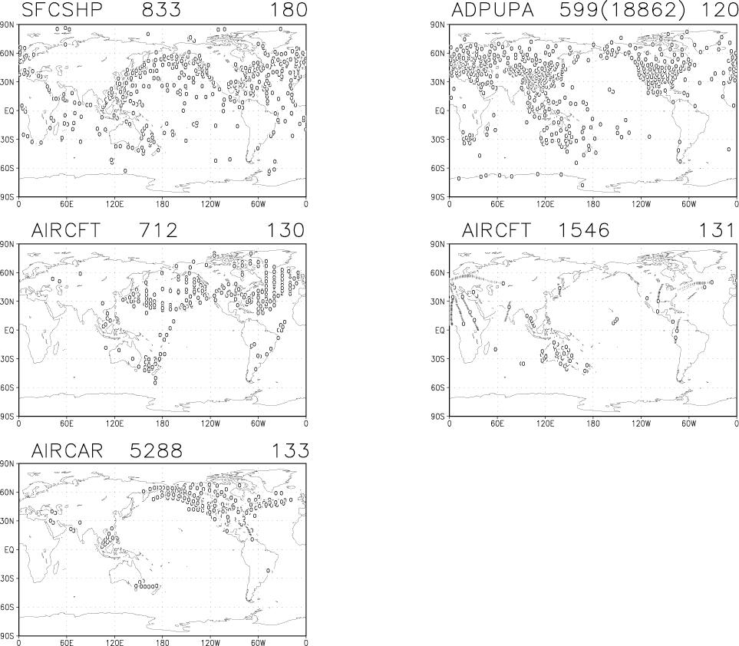
Fig 2. Distribution of temperature data. Data subset type, number of data, and data type index are shown on the each figure.

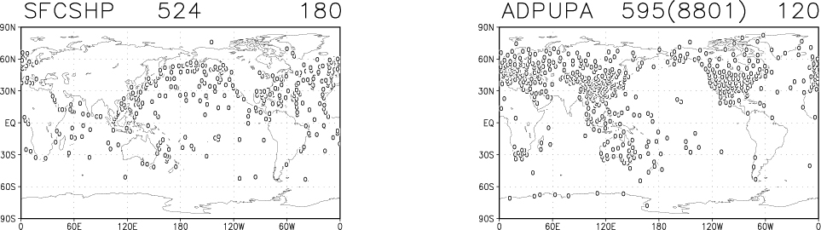
Fig 3. Same as Fig. 2 but for specific humidity.

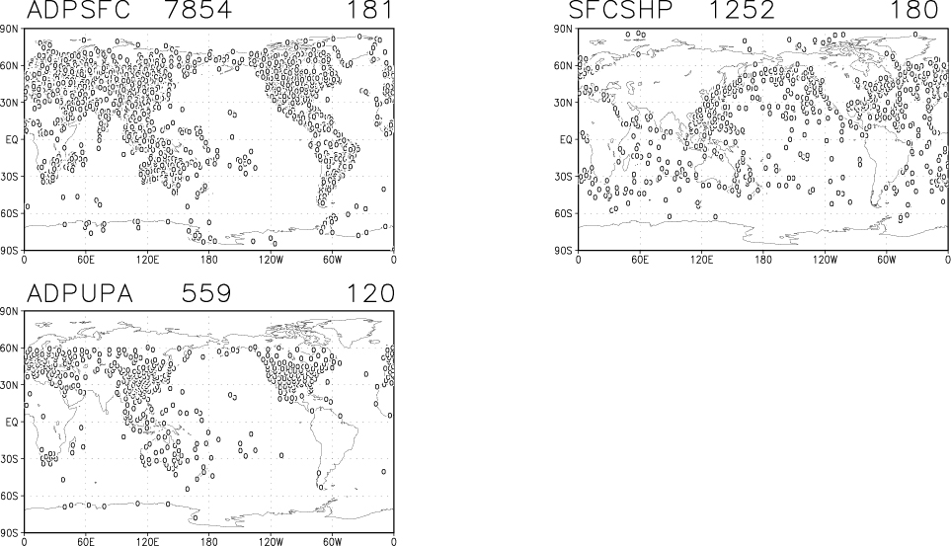
Fig. 4. Same as Fig. 2 but for surface pressure.

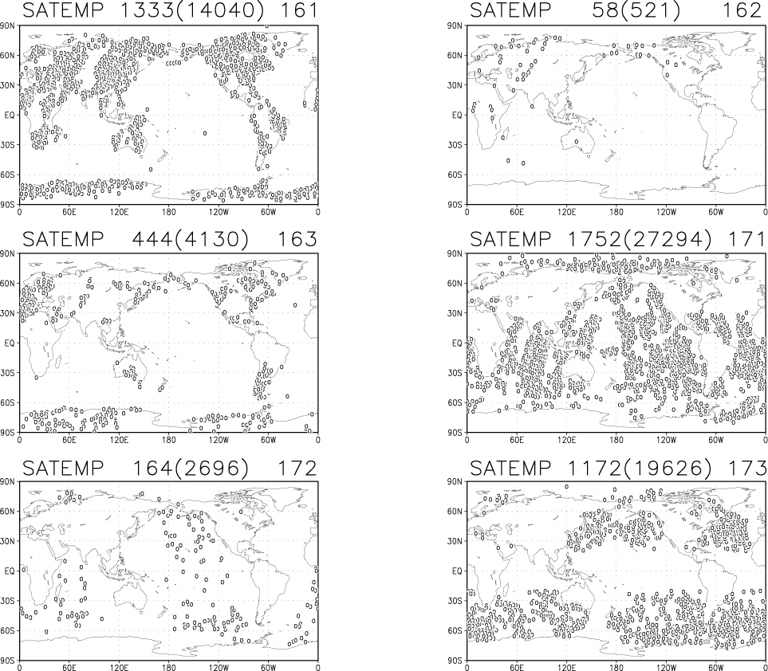
Fig 5. Same as Fig. 2 but for satellite temperature
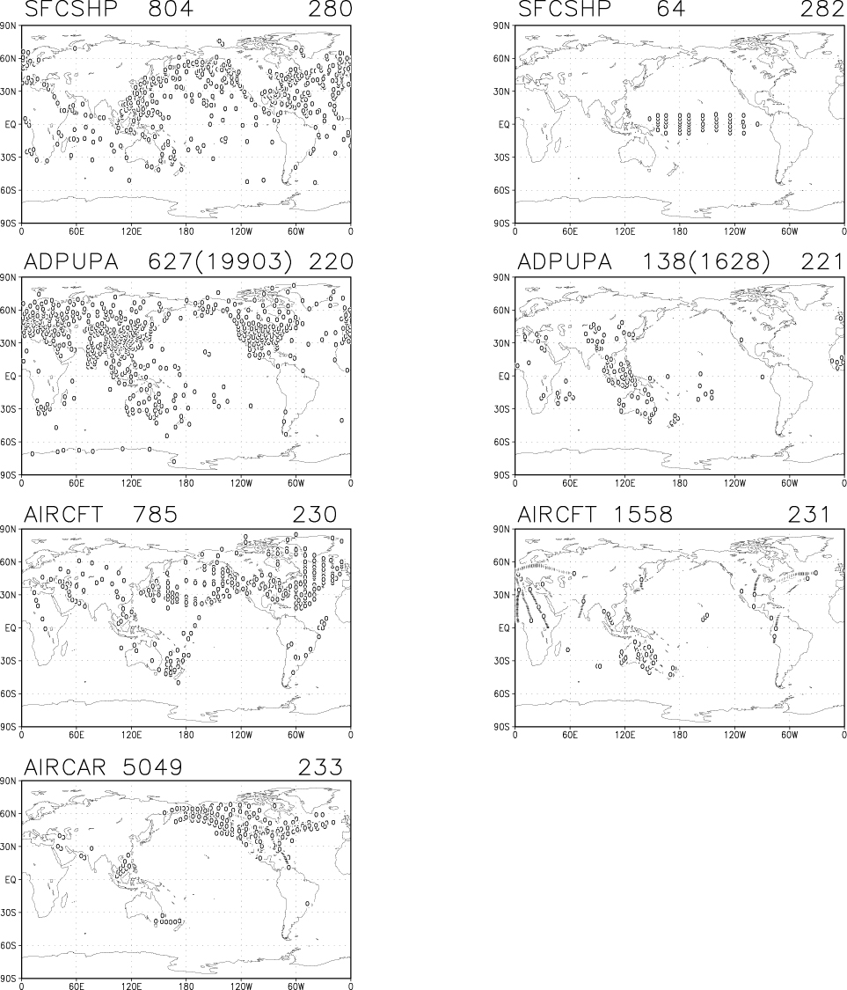
Fig. 6. Same as Fig. 2 but for wind.

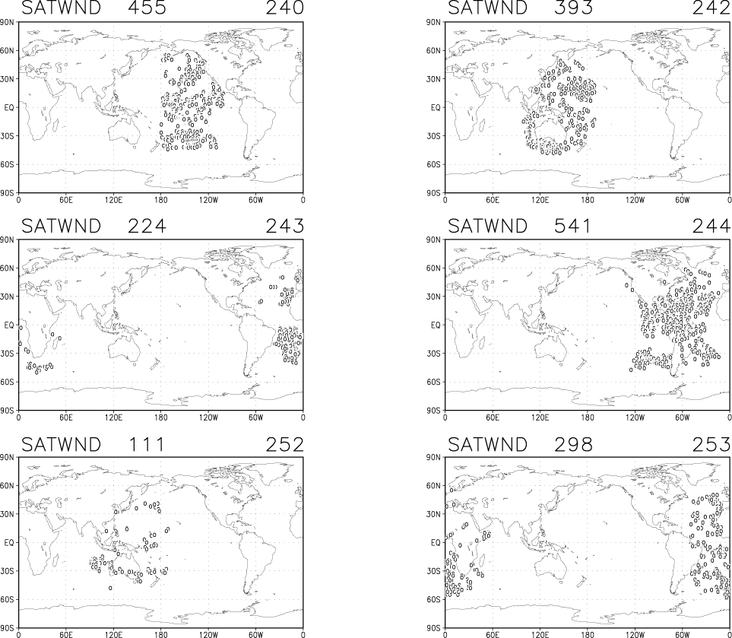
Fig 7. Same as Fig. 2 but for satellite wind.

APPENDIX: SSI structure

SSI
rdtest
glbsoi
setuprhs
pcgsoi
openbf
ufbint
closebf
inguess
rdprep
inguessv – rdgesc
rdfact
fulldivt
respsf
sprp
residw
spruv
ressat
sprs
restmp
sprt
resq
sprqpw
initps
initw
initt
satcov
initsat
initqpw
gtbhalf
gtbdivt
htoper
hoper
qoper
intps
intw
intt
satop4
intqpw
qtoper
htoper
hopers
rdgesc
Block for moisture
wranlc

if
prepp
Intrp2
prept
Intrp3
preps
Intrp3
prepw
Intrp3
prepq
Intrp3
intrp2
intrp3
intrp3
intrp3
intrp3

rdtest
openbf
ufbint – status – string - ufbrw
closebf
Read oiqc.anl.bufr

Write Psfc :: fort.84 - psdata
q :: fort.85 - qdata
T :: fort.81 - tdata
sat-T :: fort.82 - sdata
wind :: fort.86 - wdata

Data are selected accoring to quality mark

:: guess: interpolate –6hr guess into * at obs pts. with weight.

setuprhs
inguess :: read –6hr guess field

getlalo - getpln
rdprep :: read fort.8* from rdtest.f
inguessv rdgesc - s2g0 – fft99m :: read first guess. Convert to grid value
s2grad – fft99m
s2gvec – fft99m
maxmin
rdfact :: read sfc file
gdcrdp
fulldivt - grad2s – fft99m :: background error covariance
prepp
intrp2
prept
intrp3
preps
intrp3
prepw
intrp3
prepq
intrp3
respsf
sprp
residw
spruv
ressat
sprs
restmp
sprt
resq
sprqpw
intrp2
intrp3
intrp3
intrp3
intrp3
:: BUFR : lat & lon of bufr into those of gaussion grid.
Reassign error value, Psfc …
:: guess : interpolate guess into * at obs pts. with weight.

:: get residuals at obs pts.
Make 1-dim array of obs information at obs pts.

pcgsoi
initps
initw
initt
satcov
initsat
initqpw
gtbhalf :: background error covariance (eofs28126)
gtbdivt :: div-tend error variance (divterrs2812645)
htoper ts2grad- :: apply transpose of hoper, from grid to spectral.
ts2g0-
ts2gvec-

hoper s2grad :: analysis variables at spectral to grid * at gaussion
s2gvec
s2g0
qoper g2s0 :: tangent linear model for div-tend
grad2s

intps
intw
intt
satop4
intqpw
qtoper tg2s0 :: adjoint of qoper
tgrad2s
htoper ts2grad :: apply transpose of hoper, from grid to spectral
ts2g0

hopers
rdgesc
Special rutine for moisture
wranlc
if
:: Make array at gaussion grid from file containing obs info
:: Merge sat-T and conventional-T

:: apply obs. Operator

Reference
Kalnay, E., and Coauthors, 1996: The NCEP/NCAR 40-Year reanalysis project. Bull. Amer. Meteor. Soc., 77, 437-471.
Kanamitsu, M., coauthors, 2002: NCEP-DOE AMIP-II reanalysis (R-2), Bull. Amer. Meteor. Soc., 83, 1631-1643.
Parrish, D. F., and J. C. Derber, 1992: The National Meteorological Center's spectral statistical interpolation analysis system. Mon. Wea. Rev., 120, 1747-1763.

